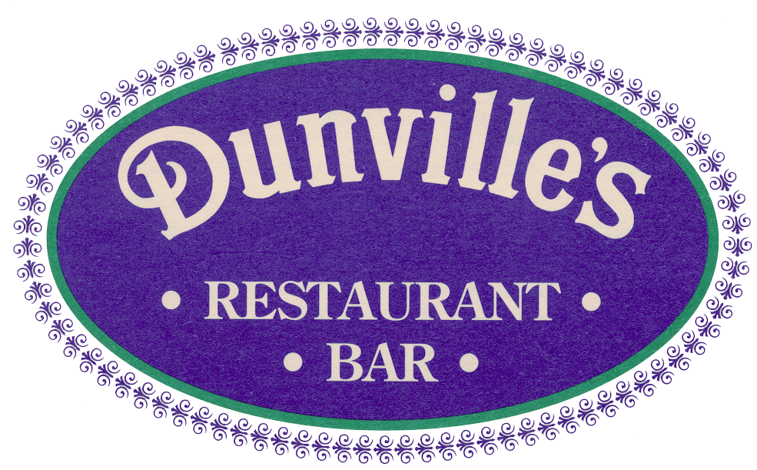

Mathew Mandall
RTM-1

As the RTM representative for the district where my restaurant is located, I am writing to you in reference to a blue law that exists in our town. This law limits our Sunday hours of operation from 11:00 a.m. – 11:00 p.m.

The permitted closing hours of operation in Westport are as follows:

Monday-Thursday 1:00 a.m.
Friday-Saturday 2:00 a.m.
Sunday 11:00 p.m.

As life long resident, as well as a restaurant owner in Saugatuck for the past 18 years, I have watched our clientele leave our community on Sundays because of the blue law. Our two closest neighbors restaurant policy, Fairfield & Norwalk, permits them to remain open until 1:00 a.m. on Sundays and reap the rewards.

With increased competition and the ever-expanding food service choices in our surrounding communities, we lose a considerable amount of revenue as a result of this law, and I am requesting that this law be amended to permit us to operate until 1:00 a.m. on Sundays during the summer.

In my opinion the majority of revenue is lost during the summer months, Memorial Day through Labor Day. It is during this time period when most of our community is enjoying the outdoor options that our town provides, causing them to arrive at local establishments at a later time than during the winter months. When informed of our early closing time, most of our clientele heads to our surrounding communities.

Any assistance concerning this matter would be greatly appreciated. Please feel free to contact me if I can be of any assistance.

Thank you in advance for your consideration.

Regards,

Stephen Carpentieri
Dunville’s Restaurant
41 Saugatuck Ave
Westport, CT 06880
(203) 227-0511

